Task 4: Research on Resume

1. Introduction
A resume is a formal document that highlights a person’s education, skills, projects, and work experience. It is used to apply for jobs and gives employers a quick overview of a candidate’s qualifications.

2. Types of Resumes
- Chronological –
  - Focuses on work experience in reverse chronological order
  - Best for candidates with consistent work history
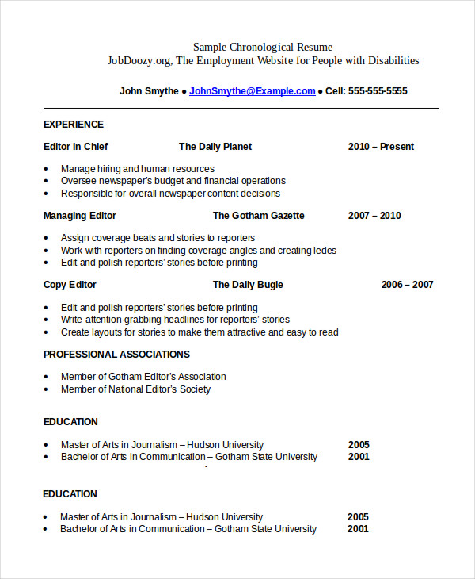
- Functional –
  - Highlights skills and abilities rather than job history
  - Suitable for freshers or career changers
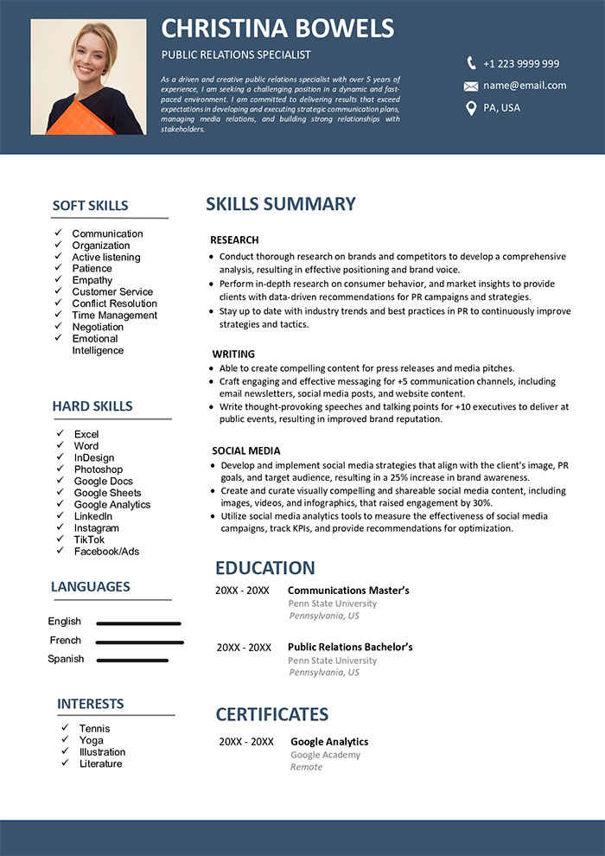

- Combination –
  - Mixes both skills and work experience
  - Useful for candidates with both strong skills and experience
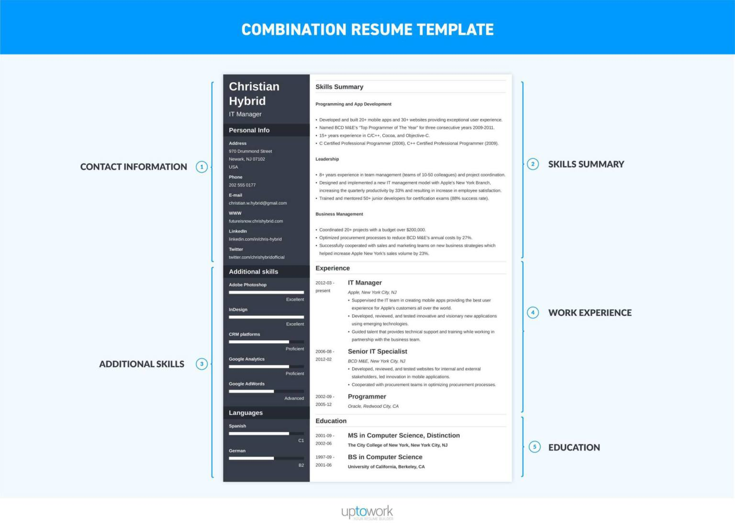
- Targeted –
  - Customized for a specific job role
  - Tailored keywords and achievements
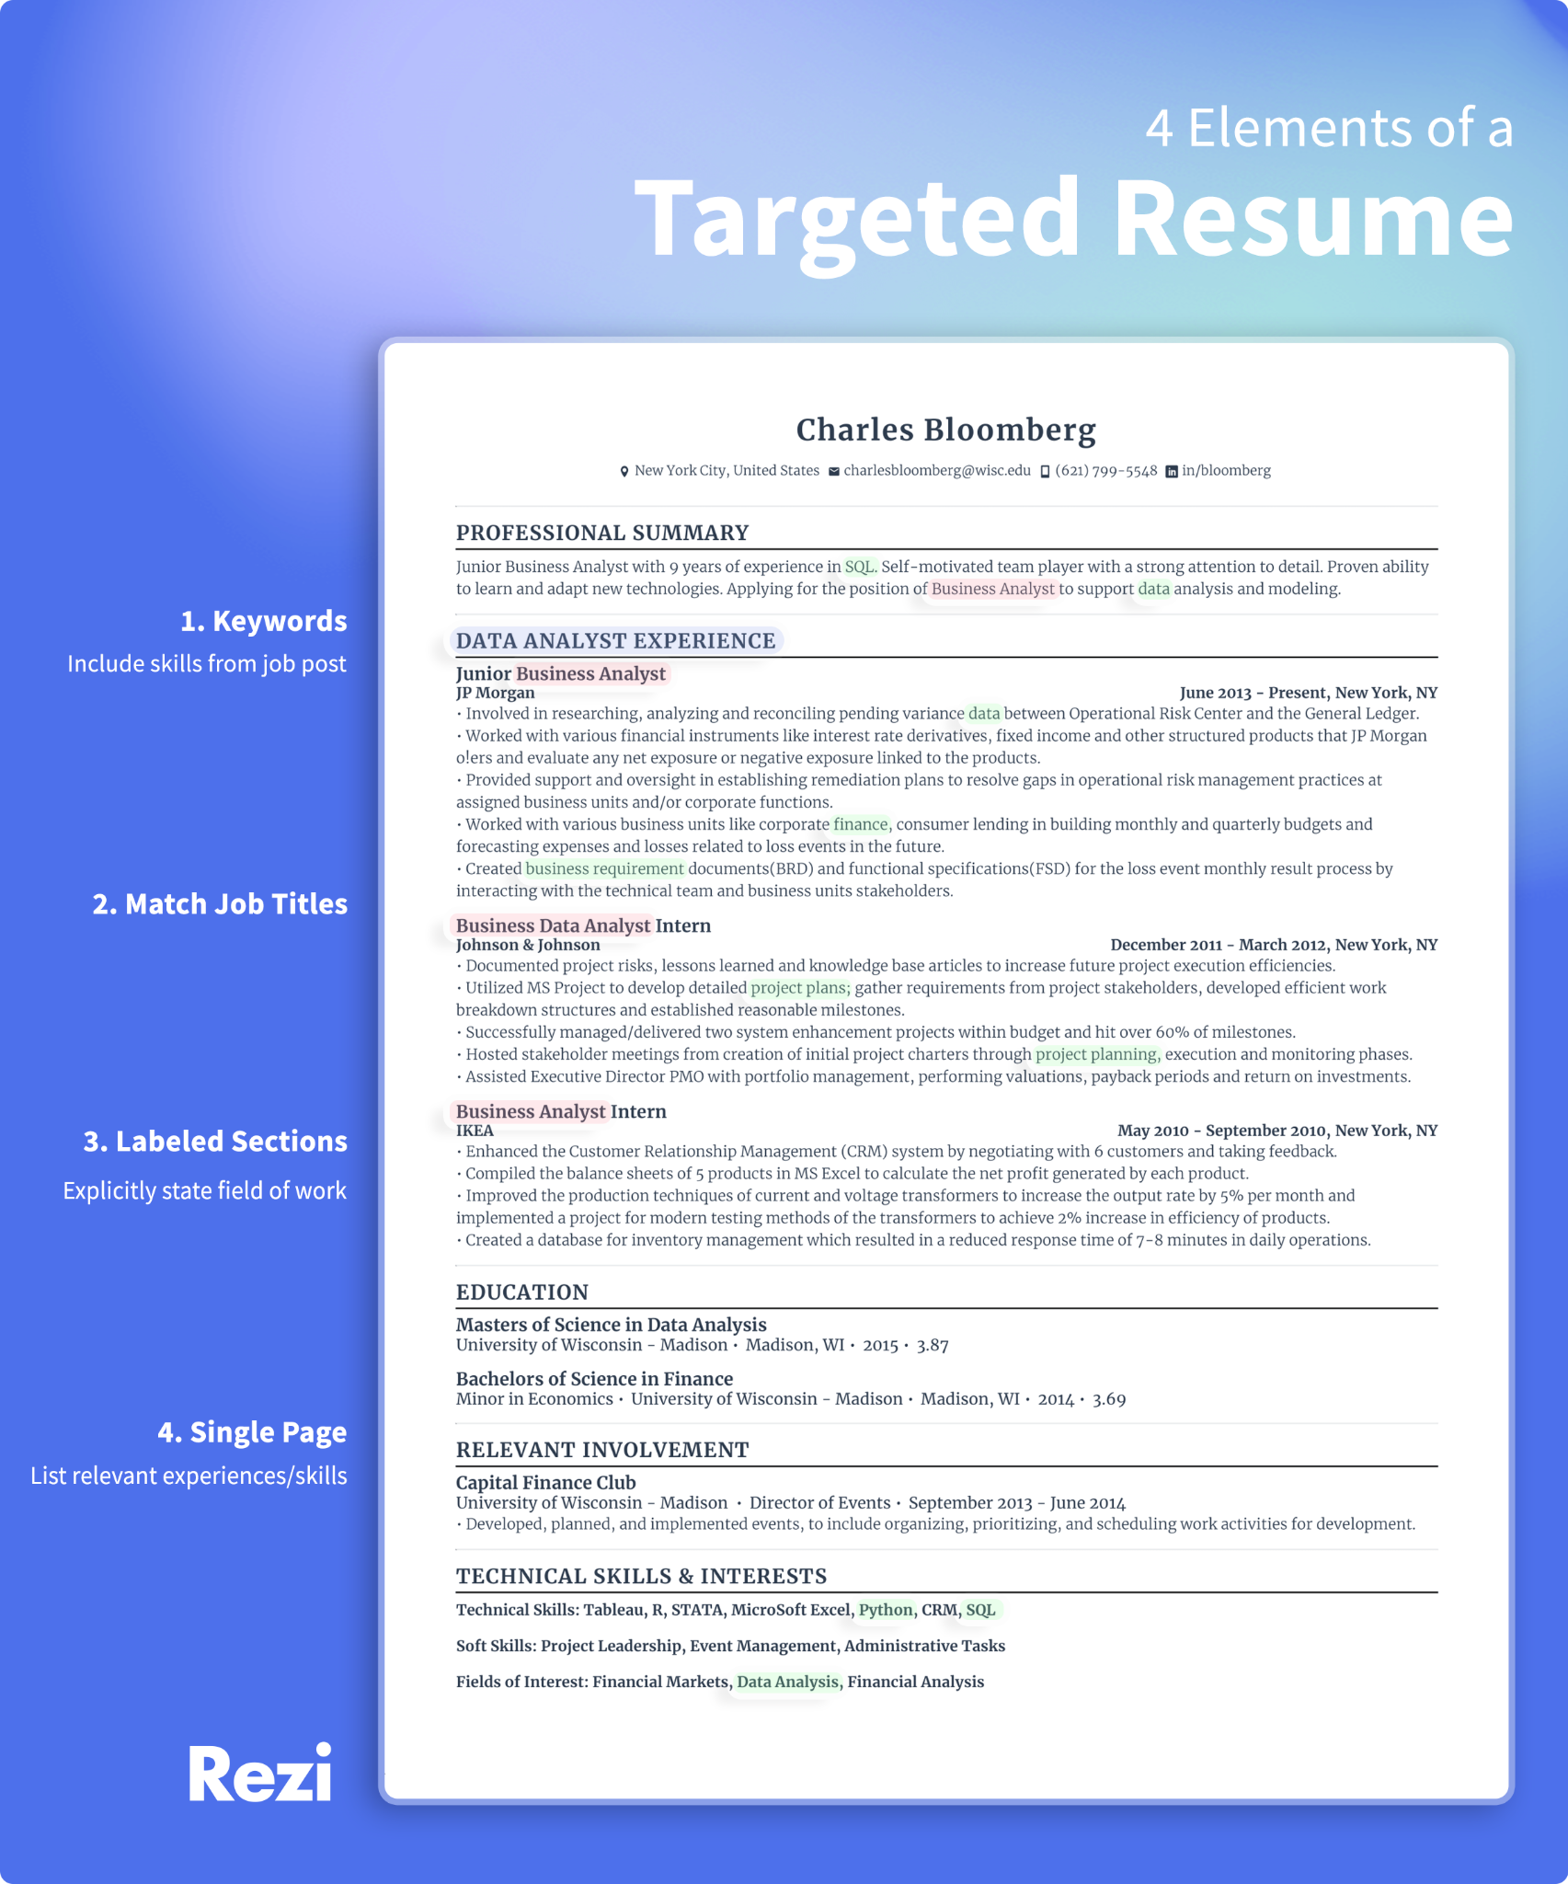

Standard Formatting Rules
  - Fonts: Use clean, sans-serif fonts like Arial, Calibri for a modern look, or serif fonts like Times New Roman or Garamond for a traditional feel.
  - Font Size: Use 10–12 pt for the body text and 14–16 pt for headings.
  - Margins: Keep them at 1 inch on all sides to ensure it doesn't look cluttered.
  - File Type: Always save the final version as a PDF to preserve formatting across different devices.

Essential Sections
  - Contact Information: Name, phone, professional email, and LinkedIn URL.
  - Professional Summary/Objective: A 2–3 sentence "elevator pitch."
  - Experience: Job titles, companies, dates, and bullet points starting with action verbs (e.g., "Managed," "Developed," "Increased").
  - Education: Degree, institution, and graduation year.
  - Skills: Hard skills (software, languages) and soft skills (leadership, communication).

Canva Resume Link (ATS format)

https://www.canva.com/design/DAG-MesRWJM/BvGYZi47yApmeXPLvBzF-Q/edit?utm_content=DAG-MesRWJM&utm_campaign=designshare&utm_medium=link2&utm_source=sharebutton

